Exercise 8 – Implementing the Strategy Pattern

Scenario
Develop a payment system that allows users to select different payment methods at runtime using the Strategy Pattern.

Understanding the Strategy Pattern
The Strategy Pattern defines a family of algorithms, encapsulates each one, and makes them interchangeable at runtime.

Project Name
StrategyPatternExample

Implementation
interface PaymentStrategy{
void pay(double amount);
}
class CreditCardPayment implements PaymentStrategy{
public void pay(double amount){
System.out.println("Paid Rs."+amount+" using Credit Card");
}
}
class PayPalPayment implements PaymentStrategy{
public void pay(double amount){
System.out.println("Paid Rs."+amount+" using PayPal");
}
}
class PaymentContext{
private PaymentStrategy strategy;
PaymentContext(PaymentStrategy strategy){
this.strategy=strategy;
}
void executePayment(double amount){
strategy.pay(amount);
}
}
public class StrategyTest{
public static void main(String[] args){
PaymentContext c1=new PaymentContext(new CreditCardPayment());
c1.executePayment(5000);
PaymentContext c2=new PaymentContext(new PayPalPayment());
c2.executePayment(2500);
System.out.println("\nStrategy Pattern executed successfully.");
}
}

Sample Output
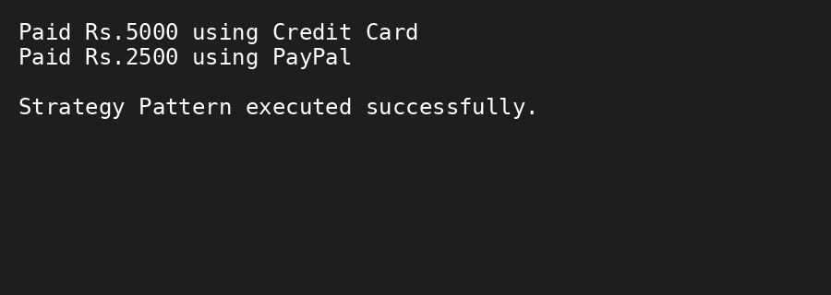

Conclusion
The Strategy Pattern enables selecting different payment algorithms dynamically without modifying existing code.

